The Portsmouth Arts Guild
Center for the Arts

Fall Classes 2015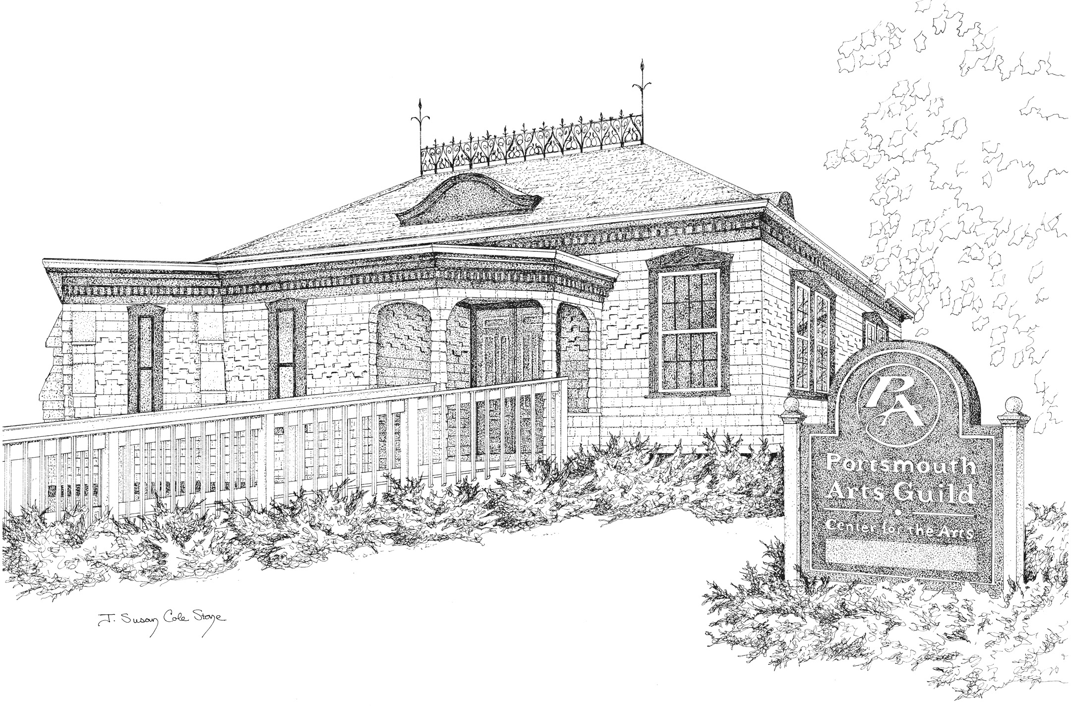
2679 East Main Road • Portsmouth, RI
www.PortsmouthArts.org

3 Day Plein Air Workshop
Learn to paint with a loose, quick and impressionistic style by learning the how to’s of composition, color and value. The first day will be held indoors and then we will head outside for some plein air painting. Take your painting to the next level with this dynamic instructor! Plenty of hands on painting and exercises. Open to oil, acrylic and pastel artists. Beginner to Advanced levels.
Instructor: Mike Rooney is one of North Carolina’s top plein air instructors. He is recognized from Cape Cod to South Florida for his energetic pure light and colorful paintings. He has been featured in articles and on the cover of Cape Cod Art Magazine. See mikerooneystudioblogspot.com
Date: Sept. 1-3
Time: 9-4 PM
Tuition: $300/$275 members

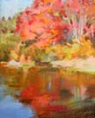
Drawing and Painting the Landscape with Amy Bartlett Wright
Autumn in Rhode Island is the perfect time to paint outside when the landscape and light is magnificent. Students of any level are welcome to learn to draw and paint in plein air using ten simple rules. Beginners are encouraged to start with drawing. We will go over concepts such as value, amount of detail, composition, color and temperature.
Instructor: Amy Bartlett Wright holds a BA in Scientific Illustration from the University of Maryland. She is a well-known illustrator and muralist for science museums, zoos, nature centers and private homes. She is a member of the Society of Animal Artists and Oil Painters of America.

Date: 4 Tuesdays, Sept 22, 29, Oct. 6, 13
Time: 2-5PM
Tuition: $140/120 members

Open figure Studio with Wayne Quackenbush
Join this 5 week open figure studio. Open to all media and skill levels. No instruction-simply an opportunity to paint or draw from live models in a friendly and supportive atmosphere. The models may be clothed or nude. There will be a series of short and longer poses depending on the wishes of the group.
Date: 5 Wednesdays, September 23, 30, Oct. 7, 14, 21
Time: 6-9 PM
Tuition: $60/50 for PAG members (tuition is to pay models)

Drawing the Portrait with Kathy Weber
Working from a live model, we will discuss the proportions of the face and how to use light and shadow to block in the features. There will be teacher demonstrations. All you will need are paper, pencils, charcoal and an eraser. This class would be a good introduction to Painting the Portrait in 4 Colors (see below).
Instructor: Kathy weber has a BFA/Painting from UMass Dartmouth. She has won numerous awards and her work has been published in American Artist Magazine. She has a background in commercial art illustration. See
Date: 2 Wednesdays, Sept. 23, 30
Time: 9:30-12 noon
Tution: $60/$50 member (model fee to be paid to instructor on first day of class)

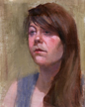
Painting Portraits in 4 Colors with Kathy Weber
Find out how easy it is to paint portraits when you use a limited palette of only 4 colors. This is the palette made famous by Andres Zorn. First we will create a color chart. Then we’ll paint from a model. You’ll see how effective these colors can be for flesh and hair colors. Oils and acrylics welcome. Some previous drawing or painting experience recommended.
Instructor: see above
Date: 5 Wednesdays, Oct. 7 (color chart), Oct. 14, 21, 28, Nov. 4 (students who have taken the class previously start on Oct 14)
Time: 9-12 noon
Tuition: $160/$150 member ($130/$120 returning students) (model fee of $40 to be paid on
Oct. 14)

Watercolor with John tolley
Learn or expand your watercolor painting skills in this fun class. We’ll work from a still life set-up and you’ll come away with several finished paintings. This is a past-time which will reward you with many hours of enjoyment to come. Open to beginners or those with some watercolor experience. Instructor: John Tolley didn’t pick up a paintbrush until later in life but has gone on to become an award-winning watercolorist. Become inspired to embark on your own journey to becoming an artist.
Date: 5 Thursdays, Sept. 24, Oct. 1, 8, 15, 22
Time: 10-12 noon
Tuition: $85/$75 PAG members

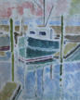
Provincetown White Line Woodblock with Suzanne Lewis
The white line woodblock was invented in Provincetown in the 1920’s. Inspired by Japanese prints, areas are delineated with wood carving tools, then painted with watercolors. They are hand printed using the back of a spoon rather than a press. Learn this unique form of printmaking now coming back into fashion.
Instructor: An award winning printmaker, suzanne Lewis has a Master of Arts in Teaching from RIC and a Certificate in Drawing and Painting Studies from RISD Continuing Education. She has been studying and practicing printmaking for many years and enjoys passing on her knowledge of this art form.
Date: Saturday, October 3
Time: 10-4 PM
Tuition: $70/$60 PAG members
($15 materials fee to be paid to instructor on Oct 3)

Playing with Color with celeste chute-wrighT (Ages 12 to Adult)
.Using the color wheel to classify colors, we will go from the nitty gritty and into the fun of understanding color theory. Each student will make their own color wheel in watercolor and then create a painting using color wheel relationships. Media of choice is watercolor.
Instructor: Celeste has studied art and painting extensively at the Visual Arts Center of New Jersey and has a fine arts degree from Union County College. She enjoys sharing her love of painting with others and teaches frequently.
Date: Saturday, October 24
Time: 10-1 PM
Tuition: $35/$30 PAG members
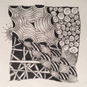
Zentangle with Libby Gilpatric (Ages 12 to adult)
Zentangle is an easy-to –learn, relaxing and fun way to create beautiful designs by drawing a series of repeating patterns one stroke at a time. Using only a pocketful of materials, it may be done anywhere, alone or in a group. The student will complete several completed Zentangle tiles of 3.5” square.
Instructor: PAG boasts the only Certified Zentangle Teacher (CZT) in the East Bay.
Libby Gilpatric is also a calligrapher and discovered Zentangle several years ago. Smitten with Zentangle’s intricate black and white patterns, she became a CZT to share her enthusiasm for the practice. Go to Zentangle.com to see examples.
Date: 3 Thursdays, Oct 29, Nov 5, 12
Time: 10-11:30
Tuition: $100/$90 members ($7 materials fee to be paid to instructor on Oct. 29)
OR
Date: Saturday, Nov 7 or Nov 21 (choose ONE or BOTH dates)
Time: 10-11:30
Tuition: $35/$30 members for each session ($5 materials fee to paid to instructor)

