The Portsmouth Arts Guild
Center for the Arts
Fall Classes 2015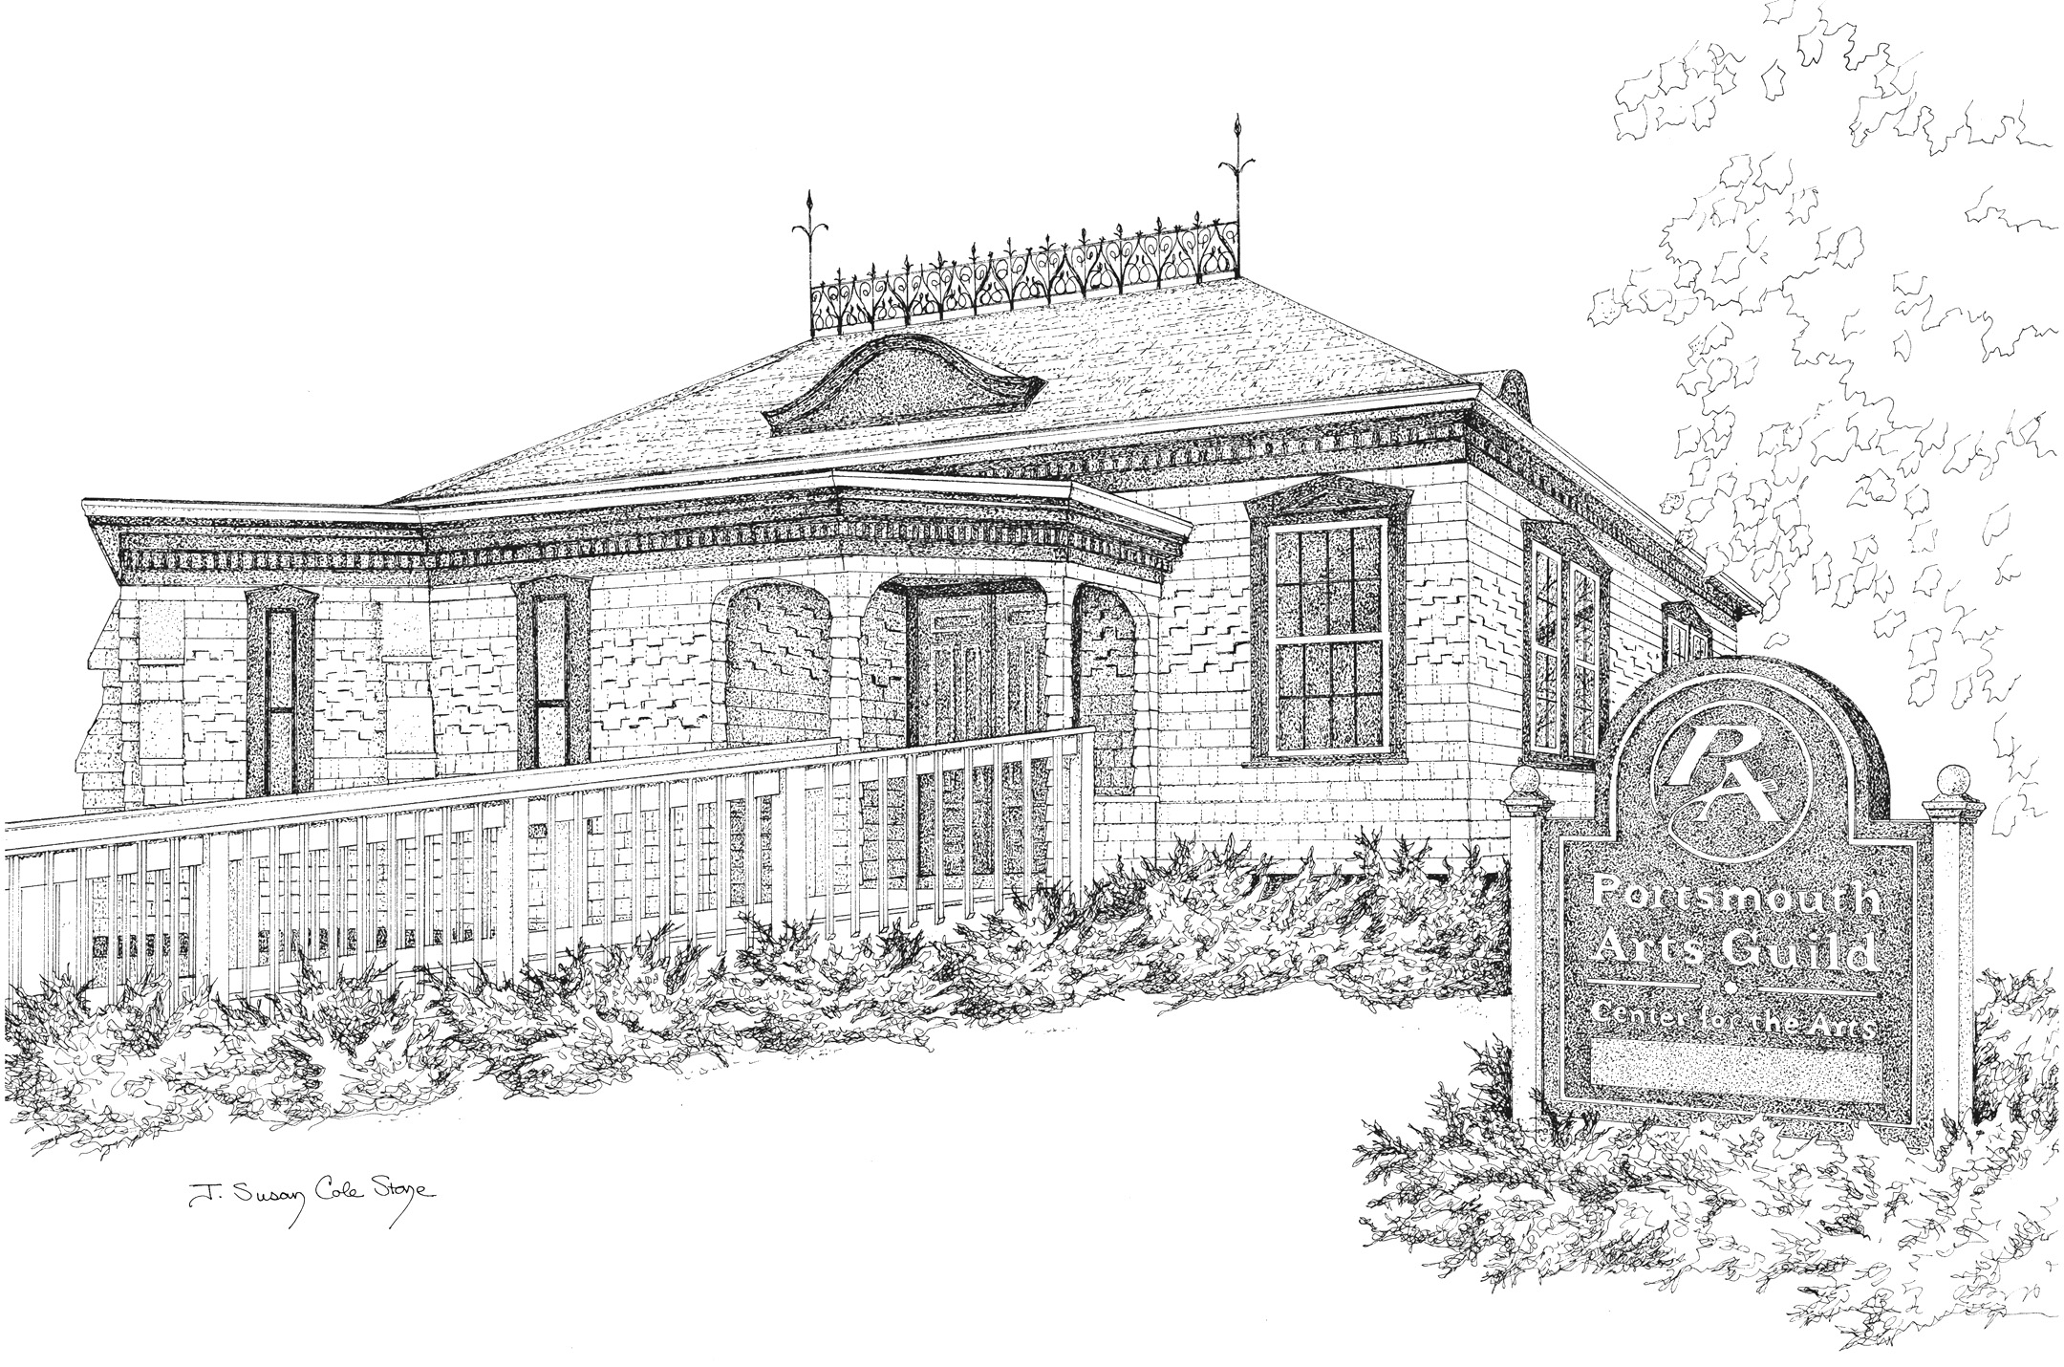
2679 East Main Road • Portsmouth, RI
www.PortsmouthArts.org

- - - - - - - - - - - - - - - - - - - - - - - - Cut and Return Form Below - - - - - - - - - - - - - - - - - - - - - -

I would like to register for ______________________________________________________
Name ________________________________________________________________________
Street _________________________________ City, State, Zip _________________________
Phone _______________ Email ________________________ Amount enclosed: $_________
You will be notified following registration of what materials you need to bring to class. If your class has a materials fee, please pay that to instructor directly; don’t include with your check.
Return to: PAG Workshops, P.O. 1181, Bristol, 02809, or contact Suzanne Lewis, Registrar, at 401-254-1668, workshops@portsmoutharts.org

